D1 - Reommendations
- Plots, Code – available in Checks notebook.
Color code:
- Recommendations
1 EDA:
Missing Ratio:
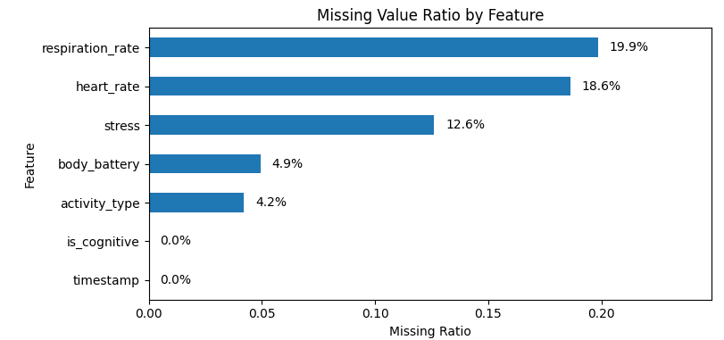
- A plot like this could be useful.
Activity Type
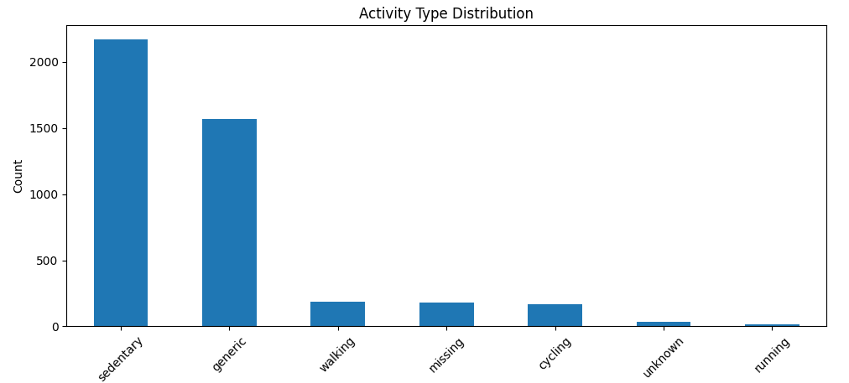
- I think generic means that Garmin Connect could not precisely determine the activity state.
- If activity type is missing I think we should use either
  - Forward fill (last activity type) – problem: if there is a big NaN gap after running forward will is not a good idea.
  - Or Generic maybe?
Time:
- It might be useful to create a column containing only the date, hour, day_of_week – and check seasonality of the features.
- 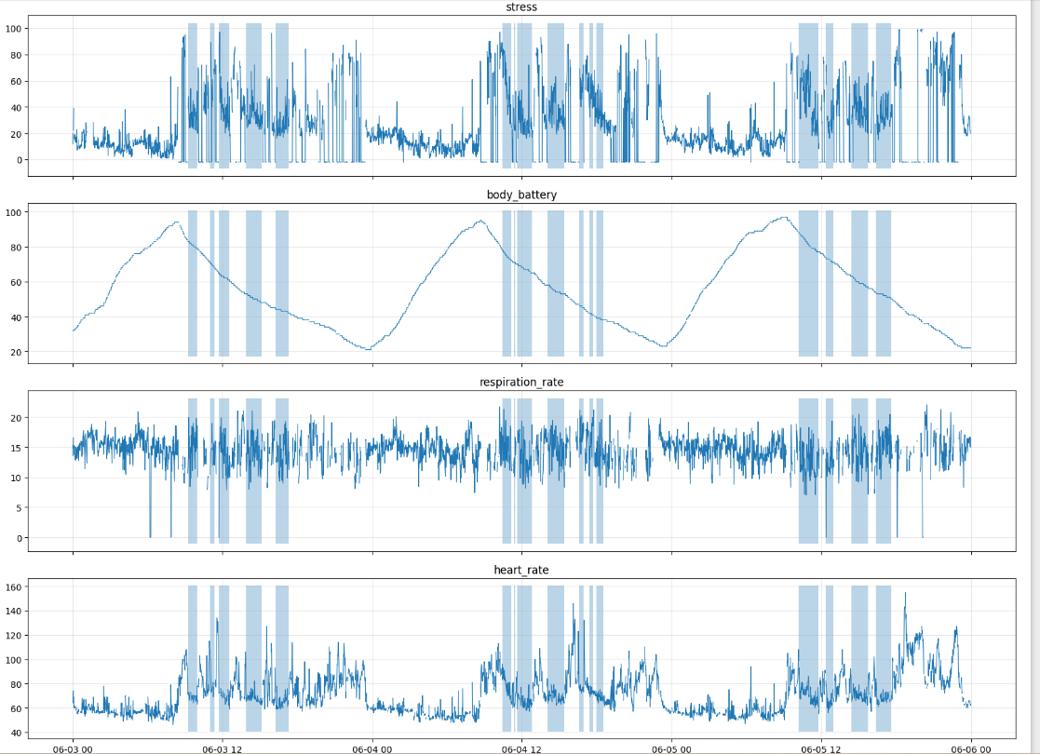
- I think this plot could be useful.
- Here the darker areas mean the cognitive periods.
- For cognitive load, we should definitely mention that it is labeled manually, and not by the Garmin Watch.
- Also we could mention that based on these plots and common sense we expect the models used later to easily identify non-sleep, and active periods and understand that mental workload cannot take place during these times. So later for evaluation it can be useful to measure accuracy for whole day, but also for non-sleep, non-active periods when the mental workload can actually take place.
2 Preprocessing:
Faulty values:
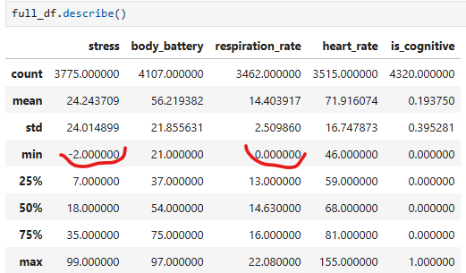
- Only these 2 seem suspcious – we should not have 0 for respiration or negative values for stress.
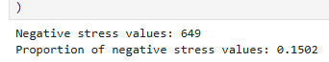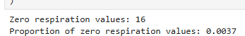
- We have 649 negative data points for stress – about 15% of the entire dataset.
- And 16 zero values for respiration.
- Important: First we have to replace these with NaN values, then we could impute the missing values with forward fill.
  - Because this is time series data I think it is better avoid linear interpolation and use forward fill instead – it might lead to data leakage because we get information from the validation set or test set if we split the dataset into train-val-test based on time.
  - But if we use forward fill, some missing values will be still in the data if a feature starts with NaN values. – we can impute these remaining ones with backward fill.
Distribution Plots
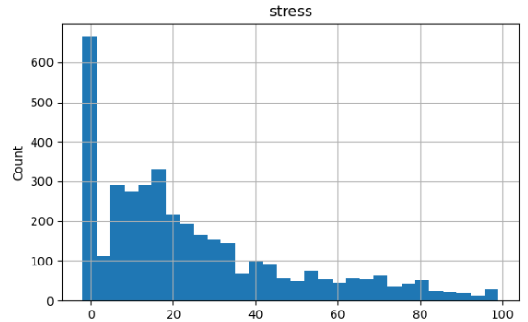
- Here the negative 2 values included – after correcting faulty values I think it is smart to plot the distributions again.
Outliers:
- I dont think we need to get rid of outliers, the rest of the data seem reasonable – Lecture 2 mentions Chauvenet’s distribution, it is applied if a distribution is roughly Normal (like respiration), but we can mention that based on the describe() function above we determined that the min-max values are reasonable apart from negative stress and 0 respiration.
Noise Filtering:
- Lecture 2 mentionds Lowpass filter (slide 35-39) for frequency noise reduction, but it might me an overkill for now, Im not sure.

